Kente Prestige Cloth
Unknown | 19th century | Record IMG-WAF0011

1. Original Image
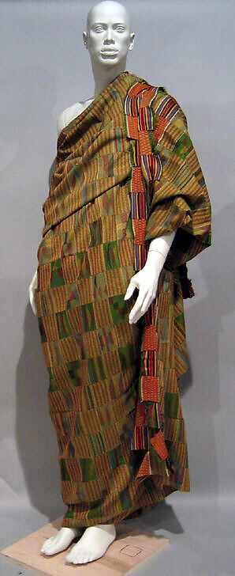
IMG-NAF0010. Kente Prestige Cloth, 19th century, Ghana, Kumasi, Asante peoples, Cotton, silk, Textiles, Purchase, Irene Lewisohn Bequest, 1972. The Metropolitan Museum of Art.

2. Record Summary
Record ID | IMG-WAF0011
Original title | Kente Prestige Cloth
English title | Kente Prestige Cloth
Alternative title | N/A
Creator | Unknown
Creation date | 19th century
Country | Ghana
Cultural region | West Africa; Kumasi
Historical period | Nineteenth-century Asante culture
Image type | Textile shown through an institutional object photograph
Medium | Cotton and silk
Dimensions | N/A
Primary subject | Kente cloth wrapped around a mannequin
Secondary subjects | Narrow woven strips, colour blocks and museum display support
Source institution | The Metropolitan Museum of Art
Collection or object number (optional) | 1972.56.1

3. Image Description

3.1 Short Description
An official museum photograph shows a large woven cloth wrapped around a grey mannequin. The textile is assembled from narrow strips with repeated rectangular and striped patterns in green, red, yellow, blue and muted brown. A brighter patterned band runs vertically along the mannequin’s right side.

3.2 Detailed Visual Description
The mannequin stands frontally against a plain grey background. The cloth passes over one shoulder and drapes toward the ankles. Much of the textile contains block-like arrangements of narrow stripes in green, ochre, brown, red and yellow.
A brighter vertical section contains alternating red, blue, yellow and dark bands. The cloth gathers in broad folds across the torso and lower body, causing patterns to bend and overlap. The mannequin and wrapping arrangement belong to the museum presentation and are not part of the original textile object.

4. Formal Features
Field | Analysis
Composition | Single central vertical figure.
Viewpoint or camera angle | Frontal standing-eye-level view.
Shot scale | Full-length object-display view.
Spatial depth | Shallow museum studio space.
Lighting | Even studio lighting.
Colour palette | Green, ochre, brown, red, yellow, blue and grey.
Contrast | Bright vertical band against a more muted field.
Visual focus | Woven strip patterns.
Texture | Dense weaving and fabric folds.
Movement or stillness | Static display with diagonal draping.
Medium-specific features | Narrow woven strips sewn together; the photograph also records museum display decisions.

5. Historical Context and Purpose

5.1 Historical Context
The Met identifies the object as a nineteenth-century prestige cloth associated with the Asante peoples and made in Kumasi. It is constructed from narrow strips of cotton and silk sewn together. The Museum notes that kente textiles may be named after warp patterns, rulers, plants, birds or animals, demonstrating that visual pattern participates in culturally specific naming systems. [IMG-0014-S01] Image Purpose and Circulation

5.2 Image Purpose and Circulation
Probable original purpose: Prestige dress and social display within Asante cultural practice.
Current institutional use: Museum preservation, display and interpretation.

